SIGN LANGUAGE RECOGNITION SYSTEM BASED ON CONVOLUTIONAL NEURAL NETWORKS (CNNS)
Design and Implementation
Department of Computer Science and Engineering, TKR College of Engineering & Technology
Batch A16 (CSE-A) · Academic year [ACADEMIC YEAR]
Table 1: Project team
S.No. | Student name | Roll number
1 | AJAY | 24K95A0502
2 | A NAVADEEP REDDDY | 23K91A0514
3 | B MANIDEEP | 23K91A0540
4 | B MAHESHWARI | 23K91A0536

Project guide: V. PALLAVI
Chapter and section numbers quoted in the text (for example Chapter 8 or Section 6.2) refer to the full project report, 17.Final Document. Figures and tables in this document are numbered from 1.

1. DESIGN

1.1 Design goals
The design follows from the requirements of Chapter 4. It must (i) run the same preprocessing and model for collection, training and recognition; (ii) keep the heavy work (TensorFlow) in one process and the camera in the browser so that no native camera code is needed; (iii) respond fast enough for a signer to see a letter within a fraction of a second; (iv) work offline on one Windows PC with no GPU; and (v) leave the original desktop application untouched so that the web version is an addition and not a rewrite.
• Reuse over rewrite. The FastAPI layer contains no recognition or training logic; every endpoint calls a function of sign_language_app.
• Stateless where possible. Only the recognition session (the smoothing history) and the training job carry state; everything else is read from files.
• Fail loudly and politely. Every endpoint validates its input and returns a clear message with a 4xx code instead of a stack trace.
• Honest numbers. The Model screen shows the true held-out accuracy of the saved model, not a figure typed into the interface.

1.2 System architecture
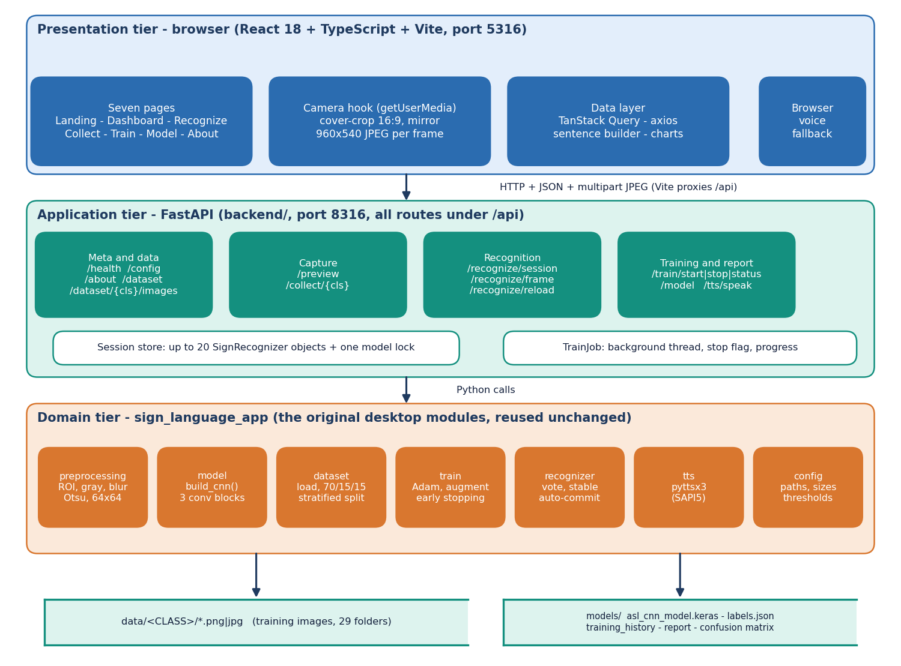
Figure 1: System architecture of SignSpeak: presentation, application and domain tiers with the two file stores.
The system has three tiers over two stores. The presentation tier is a React 18 + TypeScript application served by Vite on port 5316; it owns the webcam through the browser's getUserMedia call, cover-crops each frame to 16:9, mirrors it and uploads it as a 960x540 JPEG. The application tier is a thin FastAPI service on port 8316 (backend/): 16 endpoints under /api, a store of at most 20 recognition sessions, one lock around the Keras model and a background training thread. The domain tier is the original desktop application's package sign_language_app (preprocessing, model, dataset, train, recognizer, tts, config), reused unchanged, so the web and desktop versions cannot drift apart. Training images are kept in data/<CLASS>/ and the trained model with its reports in models/. There is no SQL database.
The browser-to-server contract is deliberately narrow: JSON for control and results, multipart JPEG for frames. In development the Vite server proxies /api to port 8316, so the interface never needs to know the API's address and CORS is not exercised; the API nevertheless allows cross-origin calls for other front ends.

1.3 High-level workflow
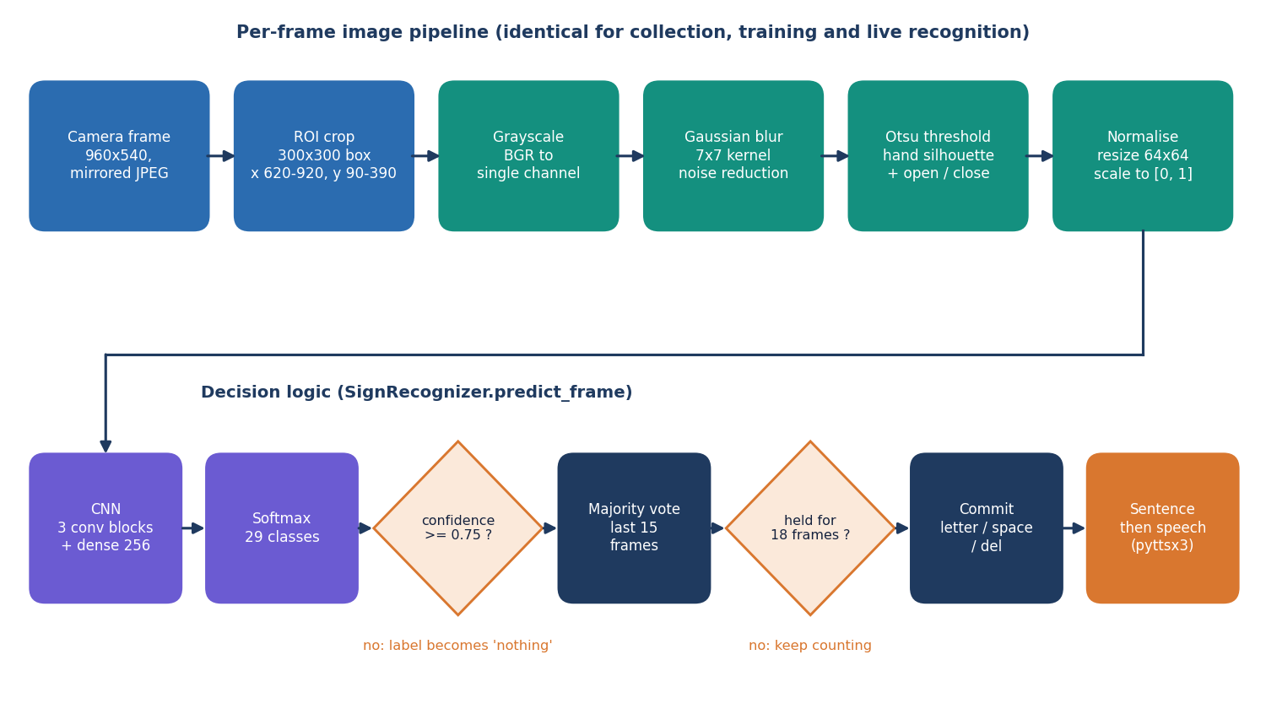
Figure 2: High-level workflow from image collection to spoken sentence.
The workflow has two halves. The offline half gathers labelled hand images (own captures in the Collect screen or the public ASL Alphabet set), preprocesses them with the same pipeline used at run time, trains the CNN with augmentation and early stopping, evaluates it on a held-out split and stores the model with its reports. The online half starts the camera, sends frames to the recogniser, smooths the predictions, appends a letter to the sentence when a sign has been held steadily, and speaks the sentence on request. Training and recognition share one preprocessing function, which removes a common source of train/serve mismatch.

1.4 Data flow diagrams

1.4.1 Level 0
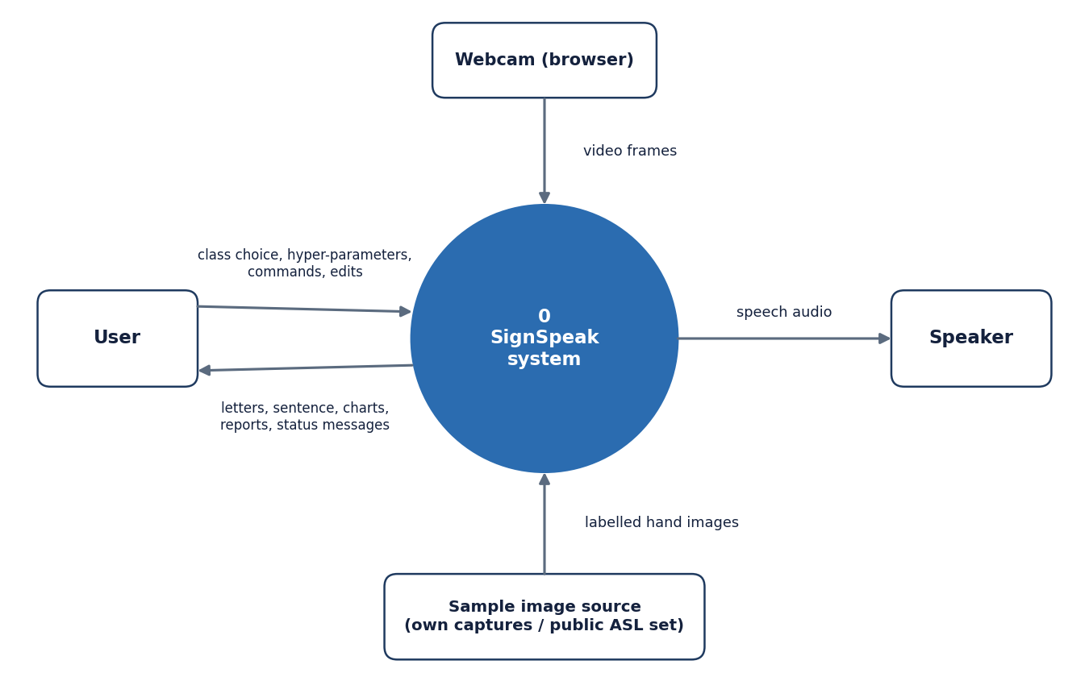
Figure 3: Level 0 data flow diagram: SignSpeak as a single process with four external entities.
At the context level SignSpeak is one process. The user supplies class choices, hyper-parameters and commands and receives letters, the sentence, charts, reports and status messages. The browser webcam supplies video frames. A sample-image source (the user's own captures or the public ASL Alphabet images) supplies labelled hand images. The speaker receives synthesised speech.

1.4.2 Level 1
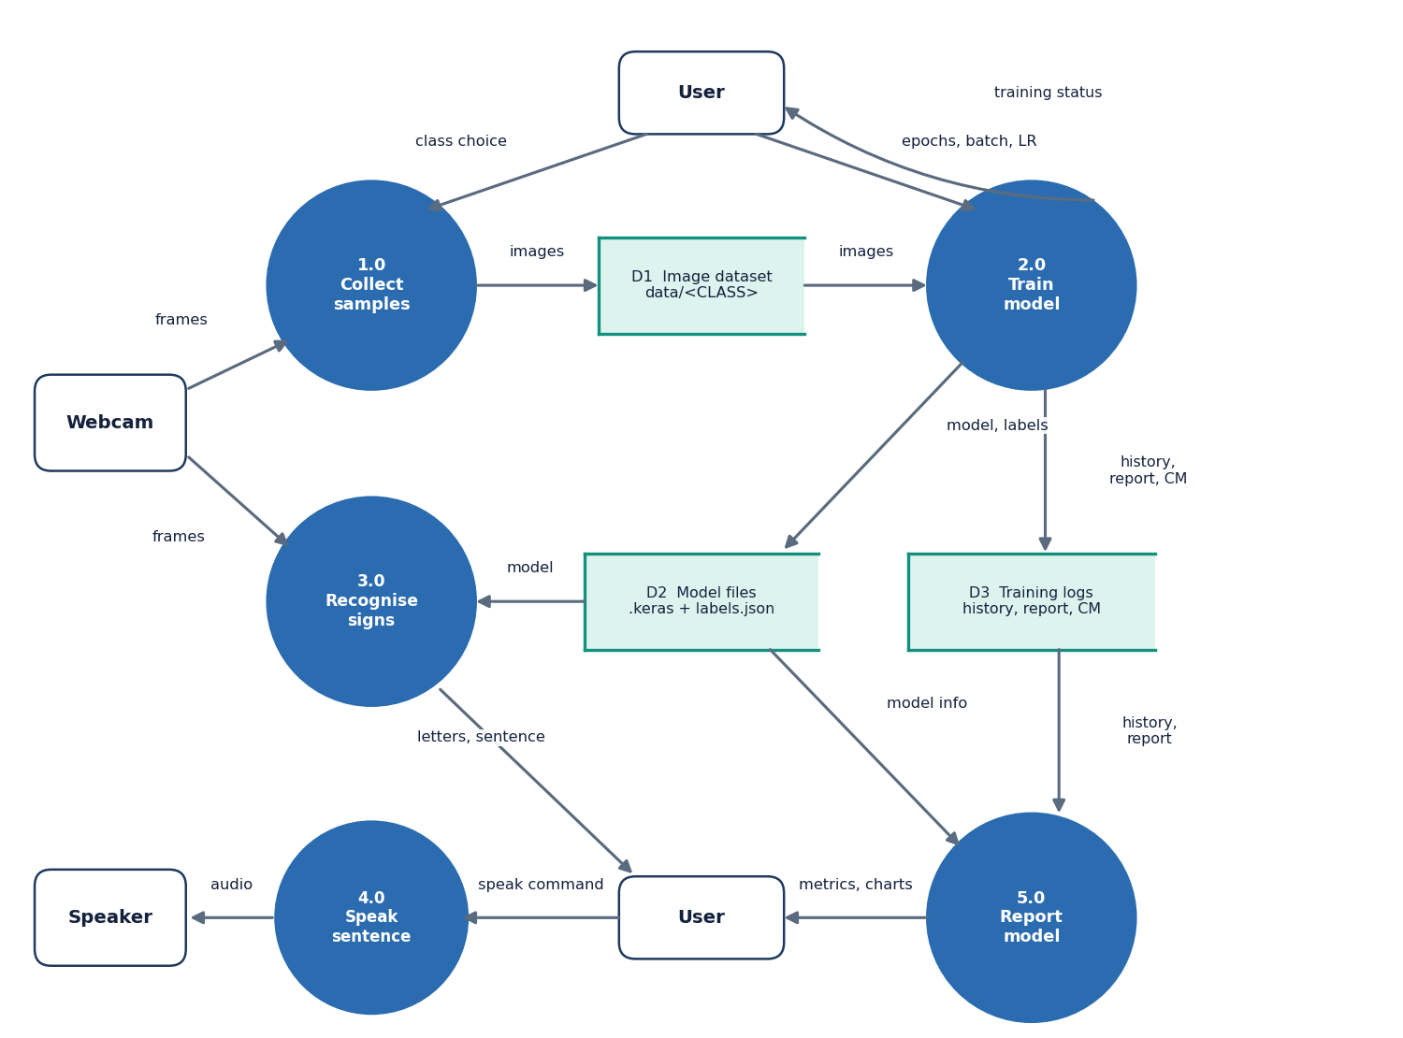
Figure 4: Level 1 data flow diagram: five processes and three data stores.
Level 1 splits the system into five processes: 1.0 Collect samples (frames in, images to store D1), 2.0 Train model (images from D1, hyper-parameters from the user; writes the model to D2 and history, report and confusion matrix to D3), 3.0 Recognise signs (frames and the model in; letters and the sentence out), 4.0 Speak sentence (text to the speaker) and 5.0 Report model (history and report from D3, model information from D2, charts to the user). D1 is the image dataset, D2 the model files and D3 the training logs. The user appears twice only to keep the arrows from crossing.

1.4.3 Level 2: recognising signs
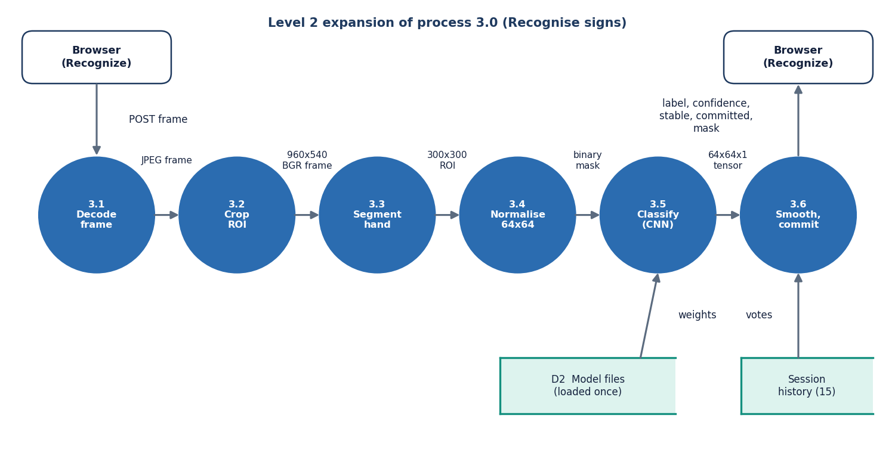
Figure 5: Level 2 data flow diagram: the six steps inside process 3.0, Recognise signs.
Process 3.0 expands into six steps that mirror SignRecognizer.predict_frame: 3.1 decode the JPEG frame, 3.2 crop the 300x300 region of interest, 3.3 segment the hand (grayscale, blur, Otsu threshold, morphology), 3.4 normalise to a 64x64 tensor, 3.5 classify with the CNN loaded once from D2, and 3.6 smooth the result with the session's history of 15 votes and decide whether to commit a letter. The result returned to the browser holds the label, its confidence, the stable label, the committed letter and the mask image.

1.5 UML diagrams

1.5.1 Class diagram
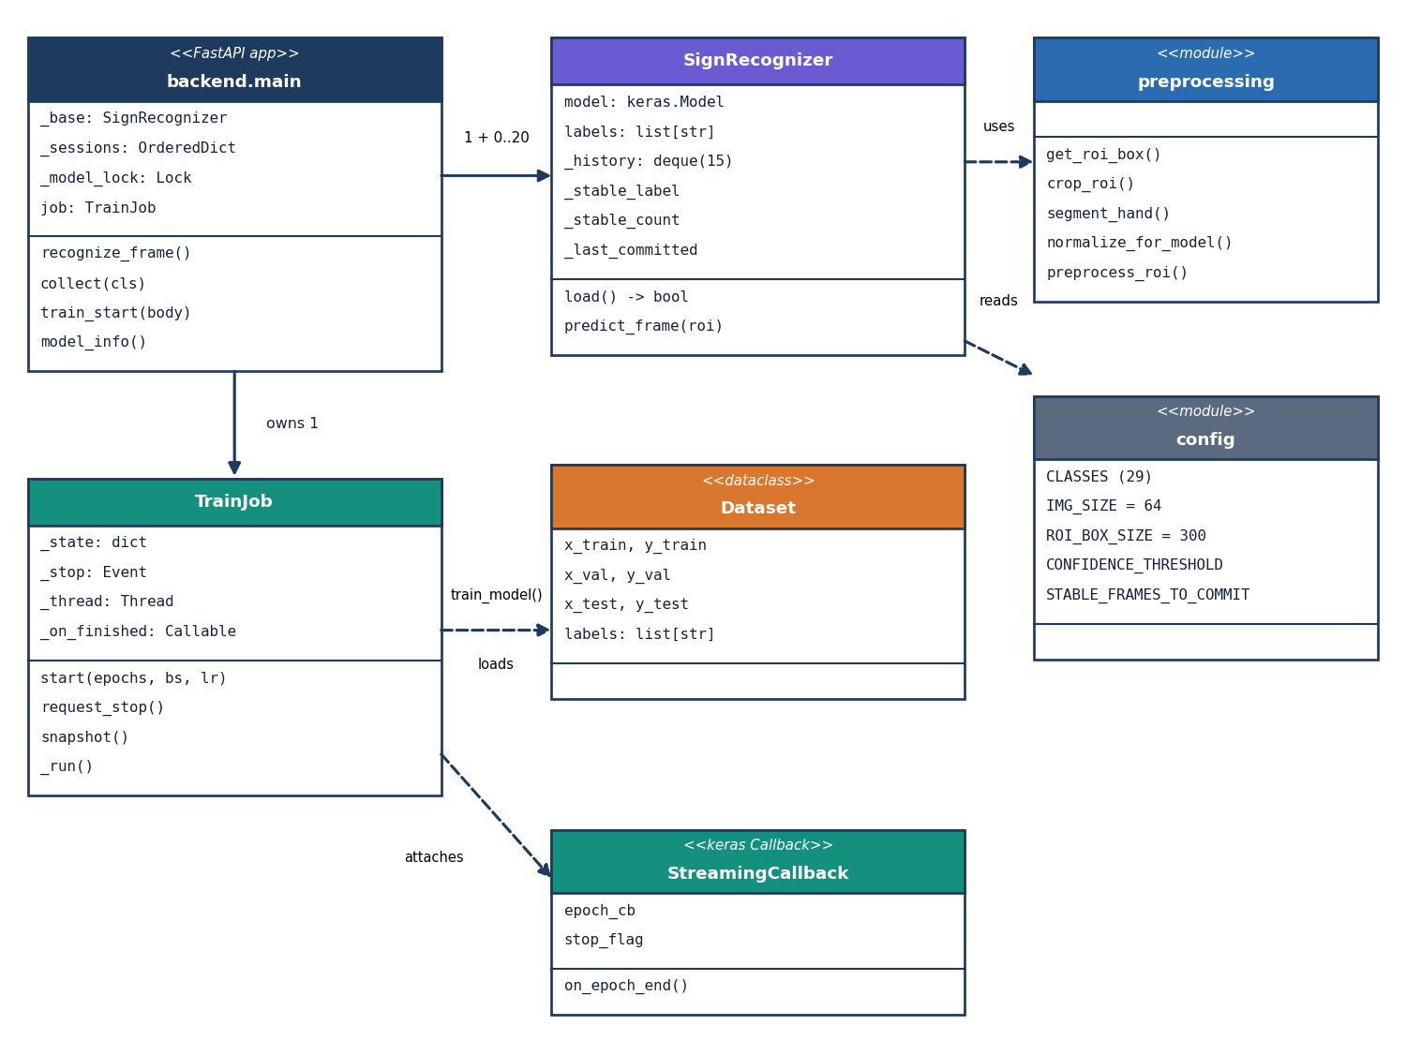
Figure 6: UML class diagram of the main classes and modules.
The code base is mostly modules of functions, so the diagram shows the real classes and the modules they use. backend.main owns one base SignRecognizer (which holds the Keras model), up to 20 per-session recognisers that share its model and labels, a model lock and a TrainJob. TrainJob runs train_model on a thread; the training code loads a Dataset dataclass (train, validation and test arrays plus the label list) and attaches a StreamingCallback that forwards each epoch's metrics and honours the stop flag. SignRecognizer uses the preprocessing module and reads thresholds from config.

1.5.2 Sequence diagram
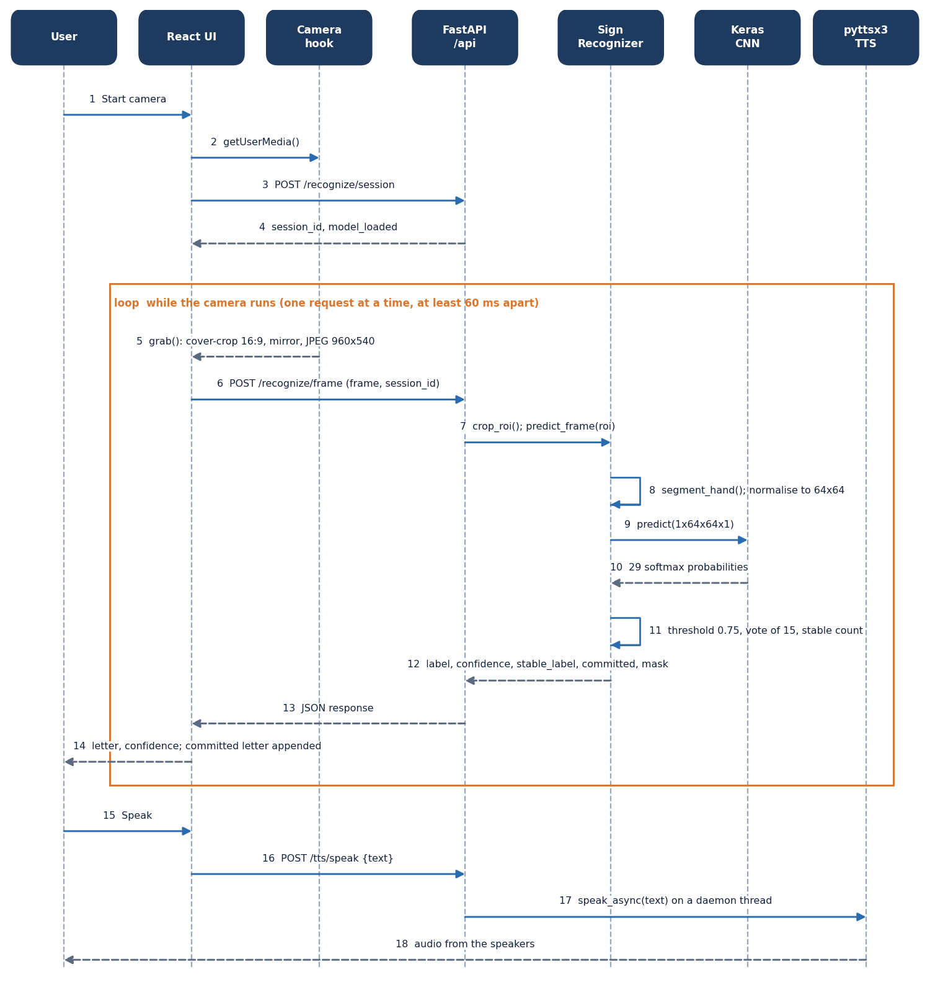
Figure 7: Sequence diagram of live recognition and speech.
The user starts the camera; the React page obtains the stream, opens a recognition session (steps 1-4) and then loops: grab a frame, post it, crop and preprocess it on the server, run the CNN, apply the threshold, vote and stable count, and return the result (steps 5-14). Only one request is in flight at a time and requests are at least 60 ms apart, so the loop cannot flood the server. Pressing Speak posts the sentence to /api/tts/speak, which starts the offline voice on a daemon thread (steps 15-18).

1.5.3 Use case diagram
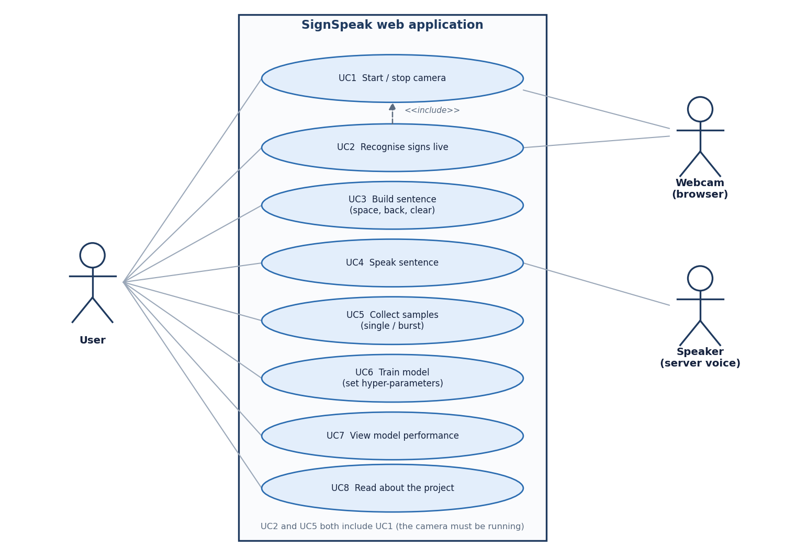
Figure 8: Use case diagram: eight use cases, one human actor and two system actors.
The user can start and stop the camera (UC1), recognise signs live (UC2), build a sentence with space, back and clear (UC3), speak it (UC4), collect samples singly or in bursts (UC5), train a model with chosen hyper-parameters (UC6), view model performance (UC7) and read about the project (UC8). UC2 and UC5 include UC1 because the camera must be running. The webcam (through the browser) and the speaker (the server voice) are the system actors. There are no accounts or roles.

1.6 Database design
A design chapter normally describes a database, so we state it plainly: SignSpeak has no SQL database. The reasons are practical. The only persistent data are image files and a model, both of which are naturally files; the user is single and local; and the session history is a transient 15-element queue. Adding a database would have added a dependency without adding a capability. The data model is therefore the file layout listed in the table below, drawn as an entity-relationship diagram after it.
Table 2: Persistent and in-memory data of SignSpeak
Location | Content | Format
data/<CLASS>/*.png|jpg | Training images, 29 folders (A-Z, space, del, nothing) | PNG 200x200 colour (own captures); JPEG 200x200 (public set)
models/asl_cnn_model.keras | Trained network (26.48 MB) | Keras native format
models/labels.json | Class order used by the network output | JSON list of 29 strings
models/training_history.json | Per-epoch loss and accuracy (train and validation) | JSON, four lists
models/classification_report.txt | Test accuracy, test loss and per-class precision/recall/F1 | Text
models/confusion_matrix.json | Labels and the 29x29 test confusion matrix | JSON
Recognition sessions | History of 15 votes, stable label and count, last committed letter | In memory only, at most 20, lost on restart

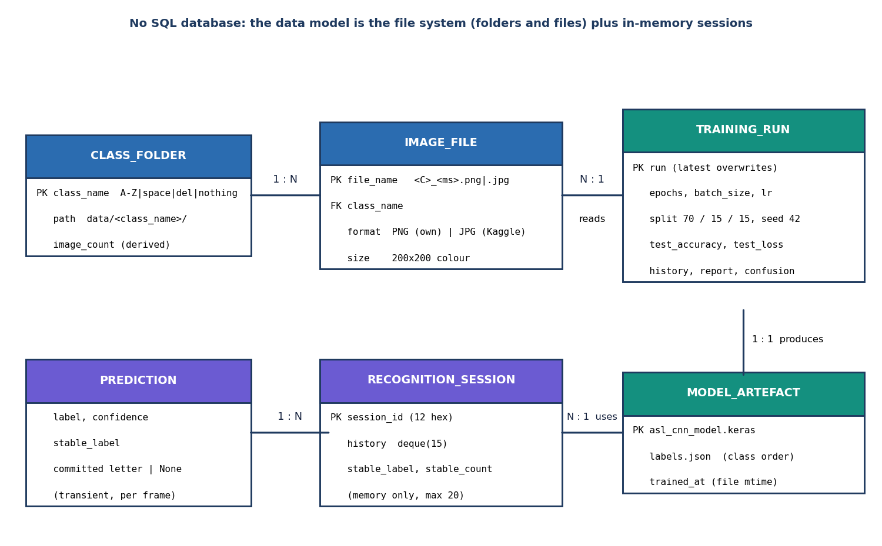
Figure 9: Entity-relationship diagram of the file-system data model; SignSpeak has no SQL database.
SignSpeak stores no records in a database. The data model is the file system: a class folder (one of 29) holds many image files; images are read by a training run; a run produces one model artefact (the Keras file, labels.json and the reports); a recognition session, kept only in memory, uses the model artefact and yields transient per-frame predictions. The diagram is drawn in entity-relationship style so that the relationships are explicit, but every PK is a file or folder name rather than a table key.

1.7 Module design
The table below lists the modules with their sizes (lines of code, measured with wc -l) and responsibilities. The desktop package is 1,648 lines, the API layer 530 lines, the web interface 5,268 lines of TypeScript and the test suite 398 lines.
Table 3: Module breakdown
Module | Lines | Responsibility | Key names
config.py | 69 | Paths, class list, image and ROI sizes, camera size, smoothing thresholds, training defaults | CLASSES, IMG_SIZE, CONFIDENCE_THRESHOLD
preprocessing.py | 102 | ROI box and crop, blur, Otsu and skin segmentation, normalisation | segment_hand, normalize_for_model, preprocess_roi
dataset.py | 109 | Class counts, loading and preprocessing images, 70/15/15 stratified split, label file | load_dataset, class_counts
model.py | 50 | The CNN architecture and its compilation | build_cnn
train.py | 121 | Augmentation, callbacks, fitting, evaluation, report and history files | train_model, StreamingCallback
recognizer.py | 86 | Model wrapper with confidence threshold, voting and auto-commit | SignRecognizer.predict_frame
tts.py | 31 | Offline speech on a short-lived engine thread | speak_async
camera.py, gui/ (desktop) | 60 + 1,019 | Threaded OpenCV camera and the customtkinter desktop interface (kept, not used by the web app) | -
backend/main.py | 367 | The 16 API endpoints, session store, model lock, report parsing | recognize_frame, collect, model_info
backend/train_job.py | 108 | Background training thread with a lock-guarded progress dictionary | TrainJob
backend/content.py | 55 | Text for the About screen (abstract, pipeline, base paper) | -
frontend/src | 5,268 | Seven pages, camera hook, data layer, charts, UI kit | Recognize.tsx, lib/camera.ts, lib/api.ts

1.8 Algorithm design

1.8.1 Core algorithm
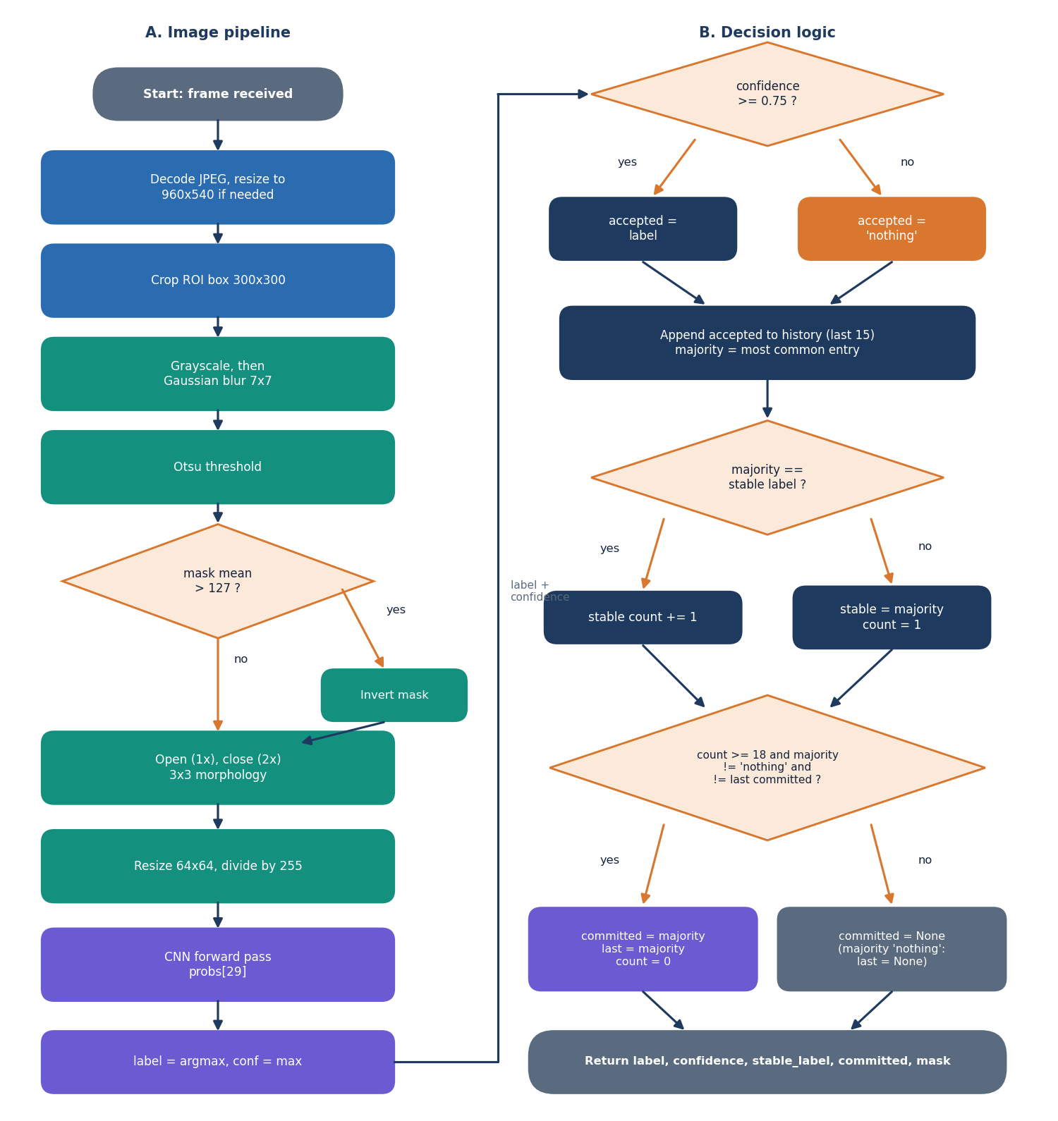
Figure 10: Flowchart of the core algorithm: (A) image pipeline and (B) decision logic.
Part A is the image pipeline: decode, crop, grayscale and blur, Otsu threshold, inversion when more than half the mask is white, morphological opening and closing, resize to 64x64, scaling and the CNN forward pass. Part B is the decision logic: a prediction below 0.75 confidence is replaced by nothing; the result joins a history of the last 15; the majority label is compared with the stable label and a counter is kept; a letter is committed when the counter reaches 18, the majority is not nothing and it differs from the last committed letter. A majority of nothing re-arms the repeat guard so that the same letter can be typed twice after the hand has been lowered.

1.8.2 Network architecture
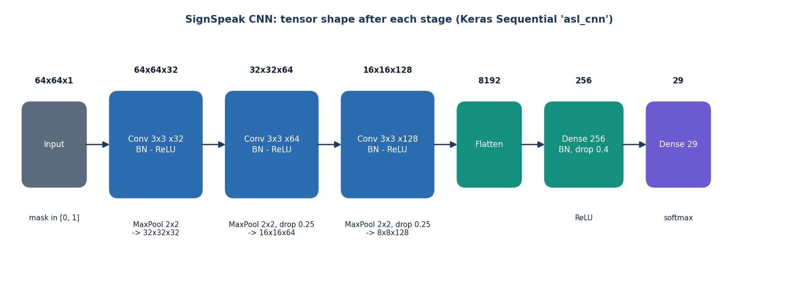
Figure 11: CNN architecture: three convolution blocks and a dense head (2,199,453 parameters).
The network takes a 64x64x1 mask. Block 1 is a 3x3 convolution with 32 filters, batch normalisation and 2x2 max pooling; block 2 doubles the filters to 64 and adds dropout 0.25; block 3 uses 128 filters with dropout 0.25. The 8x8x128 map is flattened to 8,192 values, passed through a dense layer of 256 units with batch normalisation and dropout 0.4, and a softmax layer of 29 units.
Table 4: Layers of the network
Layer | Output shape | Parameters
Input | 64 x 64 x 1 | 0
Conv2D 3x3, 32, ReLU | 64 x 64 x 32 | 320
BatchNormalization | 64 x 64 x 32 | 128
MaxPooling 2x2 | 32 x 32 x 32 | 0
Conv2D 3x3, 64, ReLU | 32 x 32 x 64 | 18,496
BatchNormalization | 32 x 32 x 64 | 256
MaxPooling 2x2 + Dropout 0.25 | 16 x 16 x 64 | 0
Conv2D 3x3, 128, ReLU | 16 x 16 x 128 | 73,856
BatchNormalization | 16 x 16 x 128 | 512
MaxPooling 2x2 + Dropout 0.25 | 8 x 8 x 128 | 0
Flatten | 8,192 | 0
Dense 256, ReLU | 256 | 2,097,408
BatchNormalization + Dropout 0.4 | 256 | 1,024
Dense 29, softmax | 29 | 7,453
Total |  | 2,199,453

Of the 2,199,453 parameters, 960 are the non-trainable moving statistics of the four batch-normalisation layers. The dense layer after the flatten holds 2,097,408 of them (95 %), which is why the model file is 26.48 MB although the network is only three convolution blocks deep.

1.8.3 Training pipeline
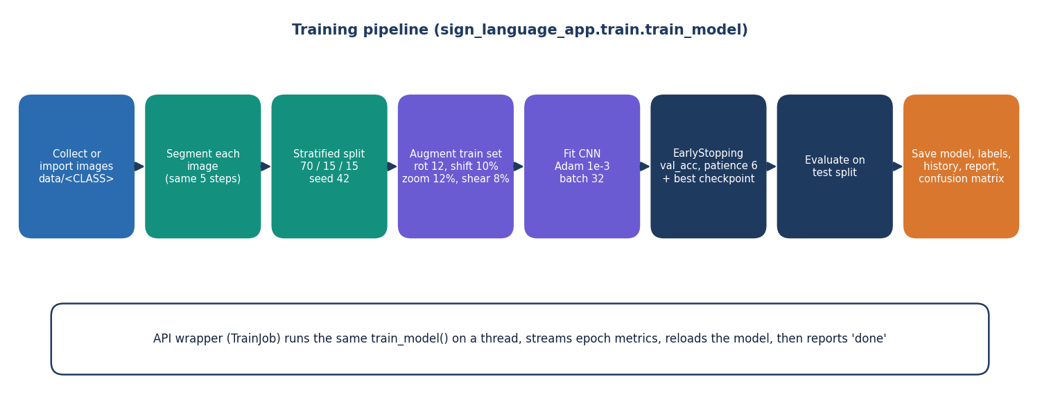
Figure 12: Training pipeline: load and preprocess, split, augment, fit with early stopping, evaluate, save.
All images in data/ are preprocessed once and cached in memory, then split 70/15/15 with a stratified split and seed 42. The training set is augmented on the fly (rotation 12 degrees, shifts 10 %, zoom 12 %, shear 8 %). Adam with learning rate 1e-3 minimises categorical cross-entropy; early stopping watches validation accuracy (patience 6, best weights restored) and the best model is checkpointed. After training the held-out test split gives the accuracy, the classification report and the confusion matrix, which are written next to the model.

1.9 API design
The API is a JSON/REST interface under /api, documented automatically at /docs (Swagger UI). The table below lists all 16 endpoints. Frames travel as multipart form data (field frame, plus session_id for recognition) because that avoids base-64 inflation of the JPEG; masks come back as small PNG data URLs. Errors are always {"detail": "message"} with a status code, which the interface shows in a toast.
Table 5: The 16 endpoints
Method | Path | Purpose | Errors
GET | /api/health | Liveness: status, model_loaded, model_file, training_state | -
GET | /api/config | Classes, frame size, ROI box, image size, thresholds, training defaults | -
GET | /api/about | Abstract, pipeline steps, base paper | -
GET | /api/dataset | Image count per class, total, trainable classes, ready_to_train | -
GET | /api/dataset/{cls}/images | Newest images of a class (limit 1-200) | 404 unknown class
GET | /api/dataset/{cls}/images/{name} | One stored image file | 400 bad name, 404 unknown
POST | /api/preview | Segmentation mask of the ROI of an uploaded frame | 400 empty / undecodable
POST | /api/collect/{cls} | Save the ROI as a 200x200 PNG; returns count and mask | 404, 400
POST | /api/recognize/session | Open a recognition session (at most 20 kept) | -
POST | /api/recognize/frame | Predict one frame: label, confidence, stable label, committed letter, mask | 409 no model, 404 session, 400
POST | /api/recognize/reload | Reload the model from disk | 404 no model
POST | /api/tts/speak | Speak text on the server (offline voice) | 400 empty or over 2,000 characters
POST | /api/train/start | Start training with epochs, batch size, learning rate | 400 out of range, 409 busy / < 2 classes
POST | /api/train/stop | Request an early stop | -
GET | /api/train/status | State, epoch, history and summary of the training job | -
GET | /api/model | Test accuracy and loss, per-class report, history, confusion matrix | 200 with trained = false when none

1.10 User interface design
The interface is a single-page React application with a landing page and six working screens (table below). It follows one design system (dark and light themes, a fixed navigation shell, cards, badges and charts from one component kit), is responsive from 360 px phones to 1440 px desktops and respects the user's reduced-motion setting. The Recognize screen is the centre of the product: a mirrored camera view with the region-of-interest box, the current letter and its confidence, the segmentation mask the network actually sees, and the sentence with space, back, clear and speak controls.
Table 6: Screens
Screen | Route | Content
Landing | / | Pitch, how it works, live pipeline preview, call to action
Dashboard | /app | Model status, image count, classes covered, accuracy, images per class, last run
Recognize | /app/recognize | Camera, live letter and confidence, mask preview, sentence builder, speak
Collect | /app/collect | Camera with ROI box, class picker, single and burst capture, recent images
Train | /app/train | Dataset coverage, hyper-parameters, progress, live accuracy and loss charts
Model | /app/model | Test accuracy, per-class table, confusion matrix, training curves
About | /app/about | Abstract, pipeline steps and the base paper

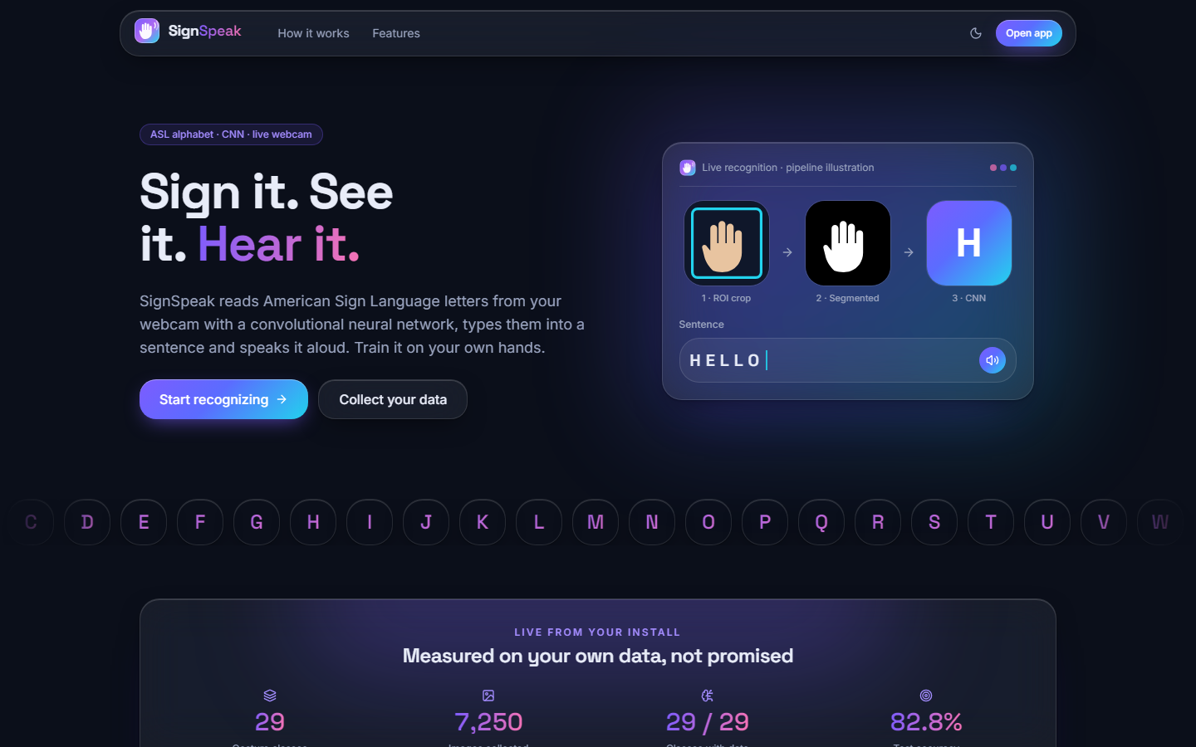
Figure 13: Landing page of the web application (dark theme).
Chapter 8 shows every working screen with real data. The visual language was taken from a component kit; the original desktop interface was not changed.

2. IMPLEMENTATION

2.1 Application architecture and implementation
Server. backend/main.py creates one SignRecognizer that owns the Keras model, loaded on a background thread at start-up so that the first page loads at once. Each browser tab opens a session: a new SignRecognizer that shares the loaded model and labels but has its own history, stable counter and last committed letter, so two tabs cannot disturb each other's smoothing. At most 20 sessions are kept (the oldest is dropped). Keras inference is not re-entrant, so every prediction and every model reload runs under one lock. Training runs in TrainJob on a daemon thread; the job's state (loading, training, done, error), epoch and history live in a lock-guarded dictionary that /api/train/status returns, and the model is reloaded before the state becomes done.
Browser. The Recognize page (pages/Recognize.tsx with lib/camera.ts) opens the camera with getUserMedia, draws each video frame to a canvas after a 16:9 cover crop and a horizontal mirror, exports a 960x540 JPEG at quality 0.8 (about 27 KB) and posts it. A new request is sent only after the previous one has returned and at least 60 ms after it was sent, so the loop cannot queue frames. The result updates the large letter, the confidence bar and the mask preview; a committed letter is appended to the sentence. The Speak button posts the text to the server voice and falls back to the browser's speech synthesis if the server voice fails. TanStack Query caches the data of the other pages (dataset counts, model report, training status, which is polled while a run is active), and Recharts draws the charts.
Desktop application. The original customtkinter application (python run.py) was kept; it uses the same modules directly and a threaded OpenCV camera. The web version was added because a browser camera needs no native camera code and gives a better interface; the two share every line of recognition logic.

2.1.1 Key code: the recogniser
def predict_frame(self, roi_bgr):
model_input, mask = preprocess_roi(roi_bgr)
probs = self.model.predict(np.expand_dims(model_input, 0), verbose=0)[0]
top_idx = int(np.argmax(probs)); confidence = float(probs[top_idx])
label = self.labels[top_idx]
accepted = label if confidence >= config.CONFIDENCE_THRESHOLD else "nothing"
self._history.append(accepted) # deque(maxlen=15)
majority_label, _ = Counter(self._history).most_common(1)[0]
if majority_label == self._stable_label: self._stable_count += 1
else: self._stable_label, self._stable_count = majority_label, 1
committed = None
if (self._stable_count >= config.STABLE_FRAMES_TO_COMMIT and majority_label != "nothing"
and majority_label != self._last_committed):
committed, self._last_committed, self._stable_count = majority_label, majority_label, 0
elif majority_label == "nothing":
self._last_committed = None
return {"label": label, "confidence": confidence, "mask": mask,
"stable_label": majority_label, "committed": committed}

The function is a direct transcription of the flowchart in Chapter 5. It returns the raw label and confidence (so the interface can show what the network sees this instant) and the smoothed result (what is typed).

2.2 Security and error handling
• Input validation. Class names are checked against the 29-name whitelist (404 otherwise); stored-image names must match [\w\-. ]+\.(png|jpe?g) and are looked up inside the class folder only, so they cannot leave it; uploads must decode as images (400); training parameters are range-checked (epochs 1-500, batch 1-1,024, learning rate 1e-6 to 1) and at least two classes must have images (409); speech text is limited to 2,000 characters.
• State protection. One model lock; one collection lock so that two frames in the same millisecond get different file names; training refuses to start while another run is active (409); a session cap of 20.
• Failure messages. Every error is a JSON message the interface shows to the user (for example No trained model is loaded. Train one first); the interface also explains camera-permission and no-camera states.
• What is not protected. The API has no authentication and allows all origins, because it is designed for one user on one machine. It must not be exposed to a network as it stands. Uploaded frames are processed in memory and are not stored except by the explicit Collect action.
The 27 API tests of Chapter 7 exercise these checks.

2.3 Installation and execution
Quick start (Windows). Install Python 3.10 or 3.11 and Node.js 18 or newer and double-click run.bat. On first run it creates the virtual environment, installs the Python packages from requirements.txt (TensorFlow 2.15.0 is large; allow several minutes) and the frontend packages, starts the API on port 8316 in its own window, starts the web application on port 5316 and opens the browser. Ports can be changed in .env. Use Chrome or Edge on localhost: browsers allow webcam access only there or on HTTPS.
python -m venv .venv && .venv\Scripts\activate
pip install -r requirements.txt
python -m uvicorn backend.main:app --host 127.0.0.1 --port 8316 # terminal 1
cd frontend && npm install && npm run dev # terminal 2
python run.py # original desktop app
python scripts/prepare_data.py [archive_dir] [per_class] # copy a 250-per-class subset into data/
python -m pytest tests # 52 tests
python scripts/smoke_test.py # 26 live API checks in a temp copy

First use. The repository ships neither the dataset nor the trained model. The user either captures images in the Collect screen (150-250 per class is a good target) or imports a dataset into data/<CLASS>/, then opens the Train screen (at least two classes are needed) and, when it finishes, the Recognize screen. Appendix B gives the full user guide.

3. KEY CODE WALK-THROUGHS
This section walks through the code that carries the design. The listings are copied from the repository.

3.1 Segmentation: from a colour crop to a hand mask
def segment_threshold(blurred_gray: np.ndarray) -> np.ndarray:
"""Otsu binary threshold -> isolates the hand silhouette from background."""
_, mask = cv2.threshold(
blurred_gray, 0, 255, cv2.THRESH_BINARY + cv2.THRESH_OTSU
)
# Ensure the hand (foreground) is the brighter region; if the mask is
# mostly white it likely inverted against a bright background, so flip it.
if np.mean(mask) > 127:
mask = cv2.bitwise_not(mask)
kernel = np.ones((3, 3), np.uint8)
mask = cv2.morphologyEx(mask, cv2.MORPH_OPEN, kernel, iterations=1)
mask = cv2.morphologyEx(mask, cv2.MORPH_CLOSE, kernel, iterations=2)
return mask

segment_threshold applies Otsu's method to the blurred grey crop. Otsu picks the threshold that best separates the two modes of the histogram, so it adapts to the exposure of each frame. If more than half of the result is white, the polarity is wrong (a bright background was labelled foreground) and the mask is inverted so that the hand is always the minority white region. An opening removes isolated specks and two closings fill small gaps in the silhouette. The unit test test_segmentation_marks_hand_as_foreground checks both polarities.

3.2 The network
model = models.Sequential(name="asl_cnn")
model.add(layers.Input(shape=(img_size, img_size, channels)))

# Block 1
model.add(layers.Conv2D(32, (3, 3), padding="same", activation="relu"))
model.add(layers.BatchNormalization())
model.add(layers.MaxPooling2D((2, 2)))

# Block 2
model.add(layers.Conv2D(64, (3, 3), padding="same", activation="relu"))
model.add(layers.BatchNormalization())
model.add(layers.MaxPooling2D((2, 2)))
model.add(layers.Dropout(0.25))

# Block 3
model.add(layers.Conv2D(128, (3, 3), padding="same", activation="relu"))
model.add(layers.BatchNormalization())
model.add(layers.MaxPooling2D((2, 2)))
model.add(layers.Dropout(0.25))

# Classifier head
model.add(layers.Flatten())
model.add(layers.Dense(256, activation="relu"))
model.add(layers.BatchNormalization())
model.add(layers.Dropout(0.4))
model.add(layers.Dense(num_classes, activation="softmax"))

model.compile(
optimizer=optimizers.Adam(learning_rate=learning_rate),
loss="categorical_crossentropy",
metrics=["accuracy"],
)
return model

Three convolution blocks (32, 64, 128 filters) each end in 2x2 max pooling, so a 64x64 mask becomes an 8x8x128 map. Batch normalisation follows every convolution and the first dense layer. Dropout of 0.25 after blocks 2 and 3 and 0.4 before the output fights over-fitting of the large dense layer. The model compiles with Adam and categorical cross-entropy, as the formulation of Chapter 6 requires.

3.3 Training with augmentation and early stopping
augmenter = ImageDataGenerator(
rotation_range=12,
width_shift_range=0.1,
height_shift_range=0.1,
zoom_range=0.12,
shear_range=0.08,
fill_mode="nearest",
)
train_flow = augmenter.flow(
dataset.x_train, dataset.y_train, batch_size=batch_size, seed=config.RANDOM_SEED
)

callbacks = [
StreamingCallback(epoch_cb=epoch_cb, stop_flag=stop_flag),
EarlyStopping(monitor="val_accuracy", patience=6, restore_best_weights=True),
ModelCheckpoint(
str(config.MODEL_PATH), monitor="val_accuracy", save_best_only=True
),
]

history = model.fit(
train_flow,
steps_per_epoch=max(1, len(dataset.x_train) // batch_size),
epochs=epochs,
validation_data=(dataset.x_val, dataset.y_val),
callbacks=callbacks,
verbose=0,
)

The augmenter perturbs the training images only; validation and test images are untouched. restore_best_weights returns the best validation epoch when early stopping fires, and the checkpoint keeps the best model on disk. In the saved run the cap of 30 epochs was reached first, so the final weights are those of epoch 30.

3.4 Frame in, decision out
@app.post("/api/recognize/frame")
async def recognize_frame(frame: UploadFile = File(...), session_id: str = Form(...)):
if not _base.is_loaded:
raise HTTPException(409, "No trained model is loaded. Train one in the Train tab first.")
rec = _sessions.get(session_id)
if rec is None:
raise HTTPException(404, "Unknown session. Restart the camera to start a new one.")
img = await _read_frame(frame)
roi = _roi(img)
with _model_lock:
result = rec.predict_frame(roi)
return {
"label": result["label"],
"confidence": result["confidence"],
"stable_label": result["stable_label"],
"committed": result["committed"],
"mask": _png_data_url(result["mask"]),
}

The endpoint checks that a model is loaded (409) and that the session exists (404), decodes and resizes the frame, crops the ROI and calls the session's recogniser under the model lock. The response carries everything the interface needs: the raw label and confidence, the smoothed label, the committed letter and the mask.

3.5 The browser capture loop
// frame loop: grab -> POST -> show prediction (about 10-15 fps, one request at a time)
useEffect(() => {
if (!running || !sessionId || !modelReady) return;
let alive = true;
(async () => {
while (alive) {
const t0 = performance.now();
const blob = await grab(0.8);
if (!blob) {
await sleep(120);
continue;
}
try {
const r = await endpoints.recognize(blob, sessionRef.current ?? sessionId);
if (!alive) break;
setResult(r);
setLoopError(null);
if (r.committed) commit(r.committed);
} catch (e) {
if (!alive) break;
if (httpStatus(e) === 404) {
try {
setSessionId((await endpoints.session()).session_id);
} catch {
/* reported below on the next failure */
}
}
setLoopError(errorMessage(e));
await sleep(1000);
}
const dt = performance.now() - t0;
if (dt < 60) await sleep(60 - dt);
}
})();
return () => {
alive = false;
};
}, [running, grab, sessionId, modelReady, commit]);

The loop runs while the camera is on and a session exists. It grabs a frame, awaits the answer, and waits for the remainder of 60 ms, so there is only ever one request in flight and never more than about 16 per second. A 404 (the server forgot the session after a restart) opens a new session automatically.

4. IMPLEMENTATION DECISIONS AND THEIR REASONS
Each decision below is stated with the alternative that was available and the reason for the choice.
Table 7: Implementation decisions
Decision | Alternative | Reason
Wrap the original desktop modules in FastAPI instead of rewriting them | Port the logic into the API | One code path; the web app cannot drift from the tested desktop logic; less code
Camera in the browser (getUserMedia) | Server-side OpenCV camera streamed to the page | No native camera code; works with any browser camera; the user sees a normal permission prompt
Send 960x540 JPEG frames (quality 0.8, about 27 KB) | Raw frames or smaller crops | Matches the desktop geometry so the same ROI box applies; small enough for localhost
One request in flight, at least 60 ms apart | Fire-and-forget at a fixed rate | Bounded load; no queue of stale frames; latency never grows
64x64 binary mask input | Colour crop at 128x128 or more | Small network, 10 s per epoch on a CPU; the mask removes skin tone and lighting differences
Otsu threshold with polarity check | Skin-colour (YCrCb) mask; hand landmarks | No extra model; adaptive per frame. Known weakness: clutter. Skin mode exists in code but was not evaluated
Three conv blocks, dense 256 | Deeper or pretrained network | Fast enough for live use on a CPU; adequate accuracy; keeps the model small enough to retrain on a laptop
Stratified 70/15/15 split, seed 42 | Signer-wise split | The dataset has no signer ids; the split is reproducible and class-balanced
Confidence 0.75 + vote of 15 + 18 stable frames | Take the single-frame argmax | Filters noise and transition frames; costs about a second of hold time
File-system storage, no SQL database | SQLite | The data are image files and a model; no queries to answer; one fewer dependency
Server voice (pyttsx3) with a browser-voice fallback | Browser voice only | Offline and consistent where available; the fallback keeps Speak working
Keep the desktop application | Delete it | It is the original deliverable and the reference implementation for the web version

